SMART Medical Service and Diagnosis System - User Guide (For Patients)

1. Introduction

The purpose of the system is to enable a website that has the ability to self-diagnose based on symptom for leg and feet injuries, book/see an appointment with a medical practitioner, search for medical facilities (for example a Hospital or GP surgery).

2. The System

The current system has selection of data for diseases relating to leg and feet symptoms. There is a selection of locations that exist in the system.

The system has a homepage what will lead to each aspect of the system, this includes:

- Diagnosis

- Appointments

- Locations

For each of these sections the following features have been implemented, please see further in the guide to see the functionality of these features.

Diagnosis:

Search for a symptom to see a list of potential disease linked to that symptom.

Appointments:

From the appointment screen, you will have the ability to see a list of all the appointments for the logged in user. If there are results for appointments, you can then cancel the appointment from these results. There is the option to add an appointment from the main appointments page.

Locations:

The location page will give you the ability to search for a postcode or a city name. The system is the able to give a list of results based off the searched criteria.

3. Installing, Starting and Stopping the System

In order to access the system please visit the following url:

<http://localhost/smms/>

From here you will be prompted to enter a login, please contact your local GP Surgery or administrator if you are yet to receive a login.

4. Step by Step Instructions for using the system

Login

In order to log in to the system you will need to enter your username and password in the below fields. If you do not currently have a log in, you will need to speak to your administrator.

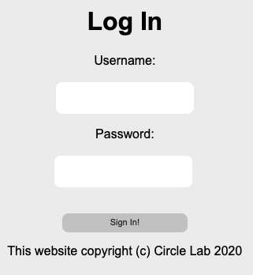

Once you are logged in you will be directed to the below page. Here you are able to select the relevant department to carry out the desired functionality.

Diagnosis Search

The diagnosis page gives you the ability to search for a symptom and see the potential disease that it could be. In addition, the recommend treatments will be listed below each disease.

Add Appointment

Coming from the homepage screen, the appointment button will lead you to the below menu:

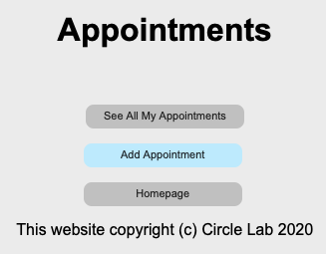

From here you will be able to add a new appointment but clicking the add appointment button. You will be prompted to enter the below details. All of these details will need to be completed in order to add a new appointment.

Once all information has been entered press the add button in order to add the appointment to the system. You will be directed to another screen confirming the appointment and the appointment details that have been added to the system.

See All Appointments / Cancel Appointment

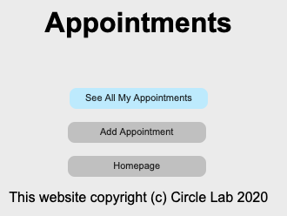

By selecting the “See All My Appointments” button the system will display all the active appointments for the currently logged in user.

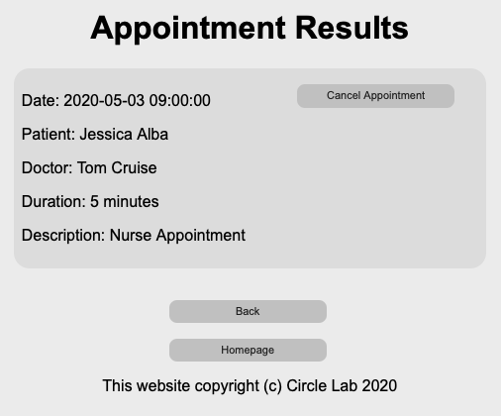

From this screen you will have the option to cancel the appointment. In order to do this, press the “Cancel Appointment Button”. Once you have pressed the button a pop up will confirm that the appointment has been cancelled. Please note that this action cannot be undone, and the appointment will need to be added again if the appointment is deleted by mistake.

Location Search

By clicking the location button on the homepage, you will be directed to the following page:

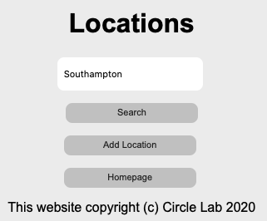

Here you will have the ability to search for a location (for example: Hospital, GP surgery, Pharmacy). You are able to enter with either the locations post code to see more details or if you search for a city you will be given a list of the locations in that city. See below for the example of searching for “Southampton”.

